Workshop 6 Acoustics
Here we employ the simplified formula (1) to calculate sound speed profiles from temperature, salinity and depth.
C(T,P,S)=1449.2+4.6T+0.055 T²+1.39 (S−35)+0.016 D (1)
From the formula, we can find that the temperature and salinity are the dominant factor to influent the sound speed. For instance, the typical range of temperature difference in Arctic region could be about [-2, 2], which will result in speed anomaly differs from -9 to 9 (m s⁻¹). In contrast, salinity ranged within [25, 35] only contribute to sound speed difference from -14 to 0 (m s⁻¹).
Typically, the collaboration effects from temperature and salinity would form a subsurface minimum of sound speed profile, as is shown in the following figure ([Talley et al., 2011]). The sound speed minimum, or SOFAR channel, generally located in 500-1000m depth.
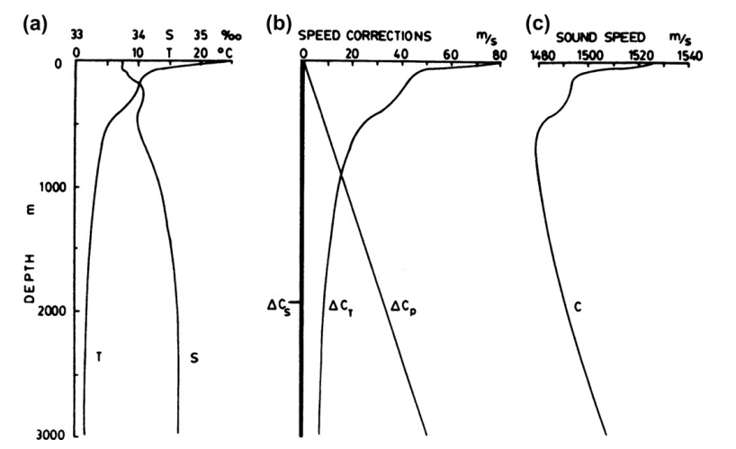
However, the sound speed profiles of ITP Buoy-70 show abnormal structure compared with typical sound speed profiles (see below). The near surface structure is mainly due to the fresh and high temperature water input from the Pacific Ocean.
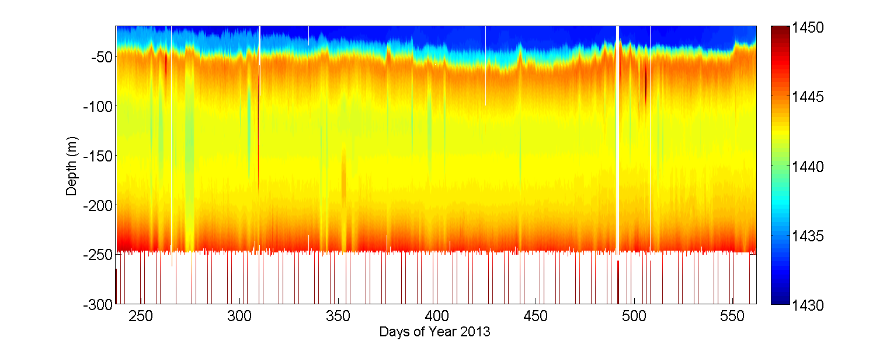
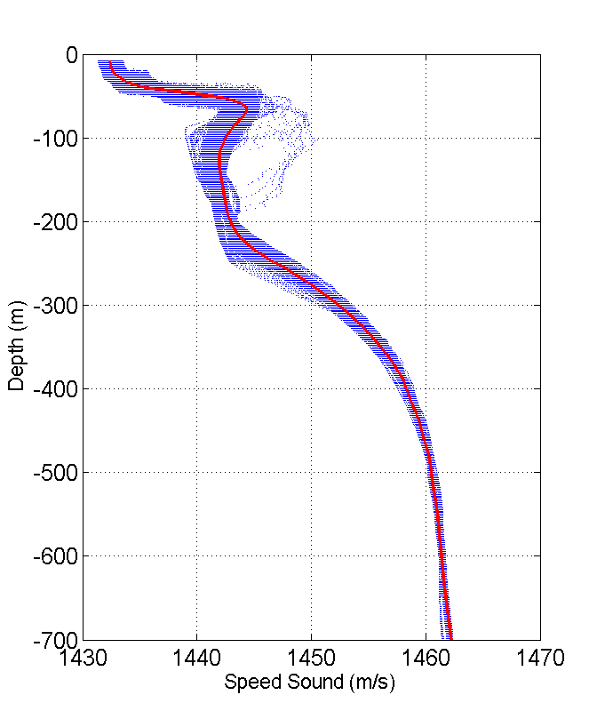
The profiles show surface minimum. It means that within the water column where ITP-70 buoy is located, the sound wave will be accumulated within shallow surface layer (~100m). Although a secondary sound speed minimum is also discernable in the profiles (~100-200m), it is unlikely that sound wave will be trapped in this layer because it is too close to surface minimum.
With respect to time, the surface layer with minimum sound speed deepens from ~10m to ~40m. The variation show similar pattern with that of N² which is likely due to the intensified wind-induced mixing. In terms of spatial variation, no significant pattern is recognized.
To further illustrate the property of sound profiles, I also calculate the second sound minimum (SSM), which is defined by the minimum sound speed under 70m. The SSM depth is as:
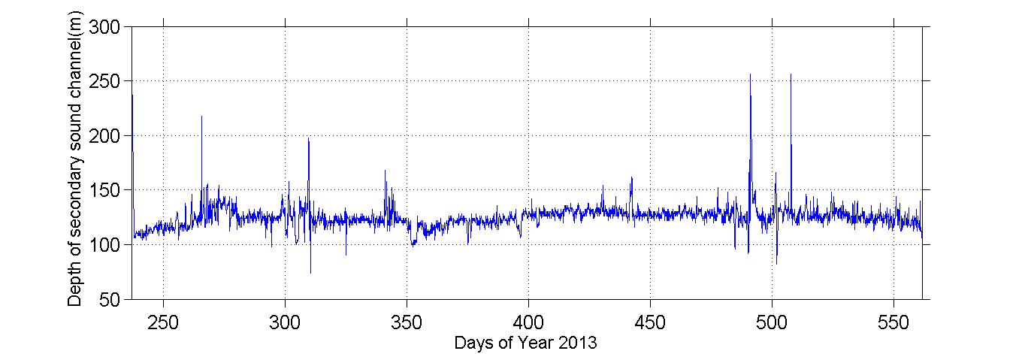
From the time series, it is obvious that the SSM is relative stable at ~125m. It is probably because the SSM is well below the thermocline, being free of surface mixing signal.
References:
Talley, L. D., G. L. Pickard, W. J. Emery, and J. H. Swift (2011), Descriptive physical oceanography: an introduction, Academic Press.
Wikipedia, http://en.wikipedia.org/wiki/SOFAR_channel

